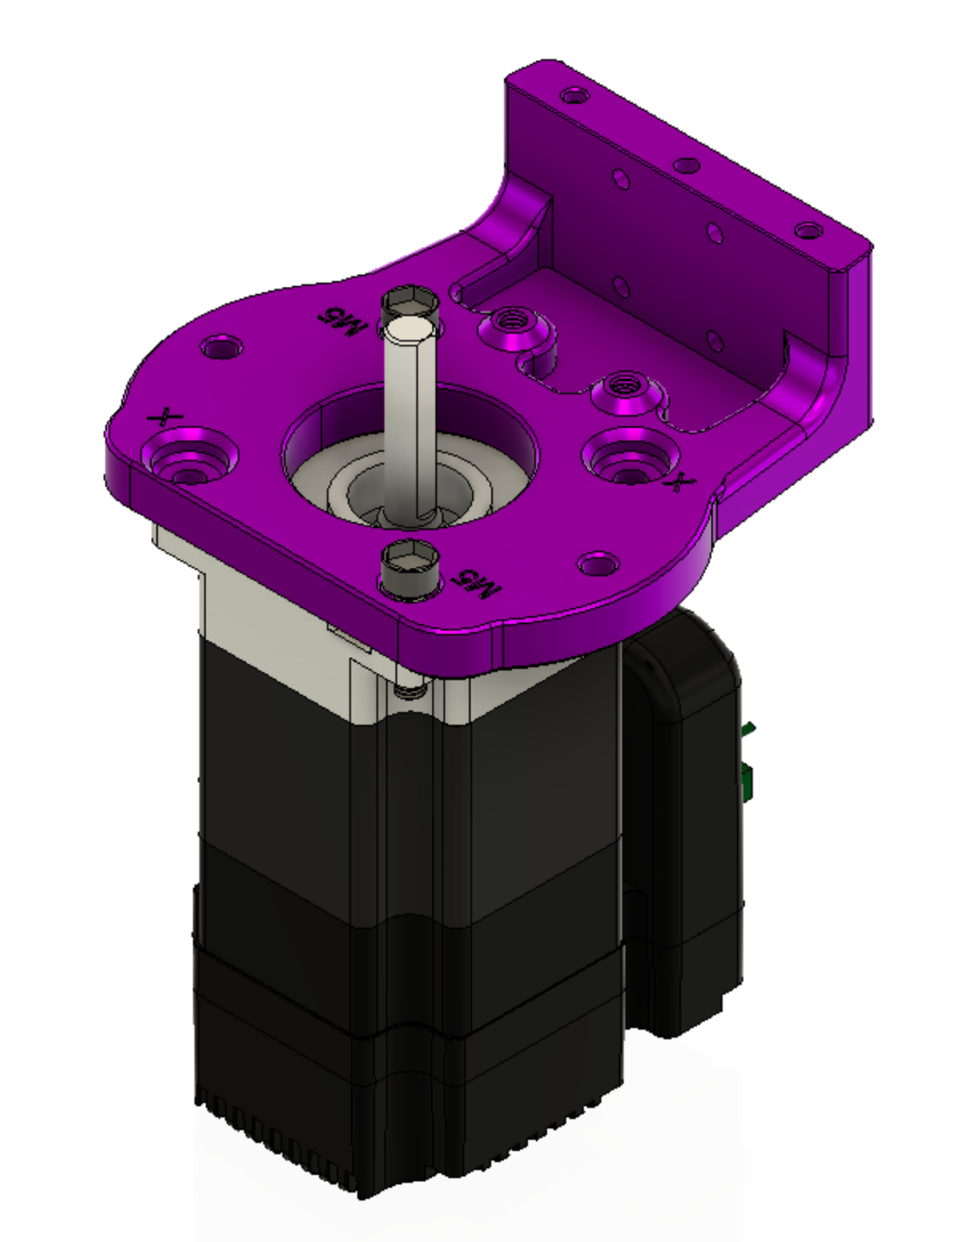Attach the OSSM base plate to the motor with (2) 5x20mm cap head screws in the locations marked *M5* and tighten with a M5 nut below the motor mounting flange.

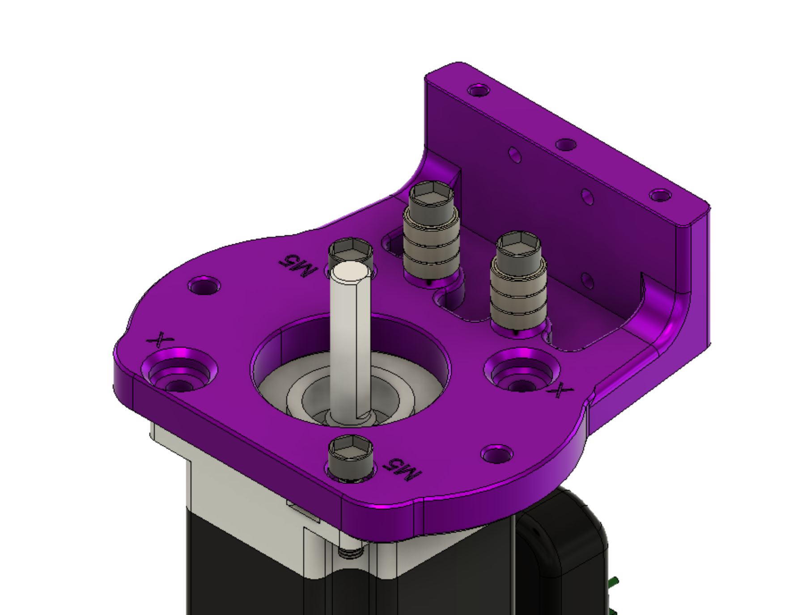

The bearing stacks are built up around 5x20mm cap head screw

Stack three 5x11x4mm bearings on a 5x20mm cap head screw and attach to the threaded positions in the baseplate as shown above.

Mount the 20 tooth GT2 Pulley on the shaft of the motor

Align the pulley so that it is within the range of the bearings and the set screws that clamp it to the motor shaft are available from above the base plate

MGNRH Rail and Bearing are next*. linear rail is omitted from this view.*

**Try not to separate bearing from linear rail, there is a chance of losing ball bearings when the rail and bearing are separated**

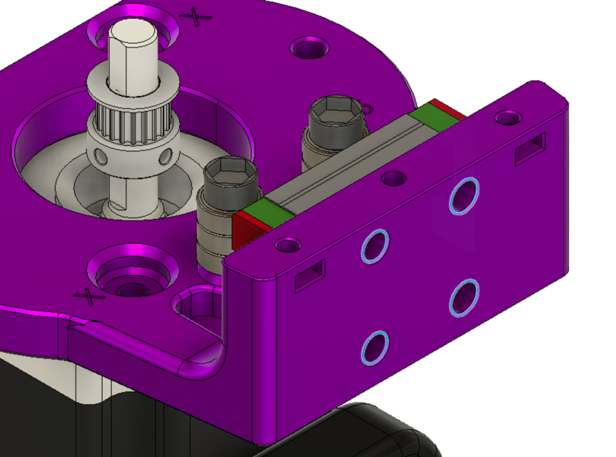

Highlighted holes for M3 cap screws. The cap screws should finish flush with surface when fully tightened.

Attach the middle part of the OSSM body utilizing the remaining diagonal holes. The M5x20mm shown above being inserted into the correct positions.

Now is time to place the belt in the iconic OSSM configuration. Using the clamp files provided to secure and tension the belt.

Editors note: more detailed clamp views to follow.

The Double Double adapter can now be secured to the end of the rail. There are other options as well, all the official end effectors attach in a similar manner. 2x M3x20mm are secured through the adapter and the rail.

Congratulations!

(we hope) You should now have a mechanically assembled OSSM that looks something like this;

